A Grade 3-5 ARTful Hour
April. 2014 with Heidi Stoddart

Visual Art Resource Binders K-8 on the DOE Portal

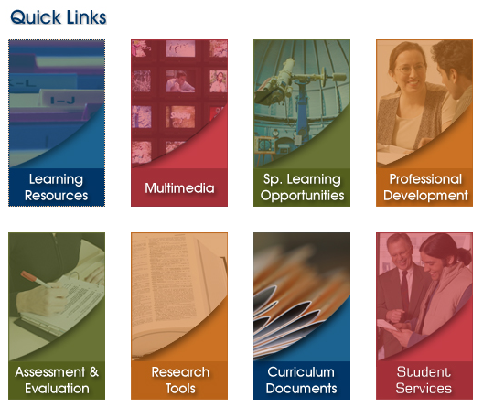
1. Click on
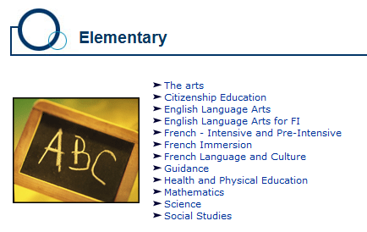
“Learning Resources”
2. Under ‘Elementary”,
click on “The Arts”

3. Scroll down to “Visual Arts Resources
Binders K-8” and click on the Grade Level
of your choice

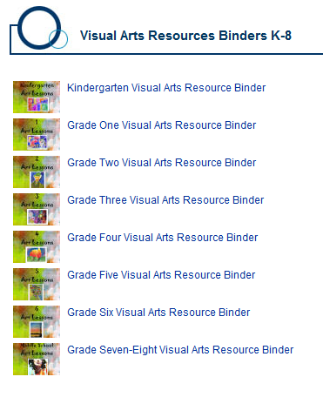

Sample Lessons that we’ll try today:
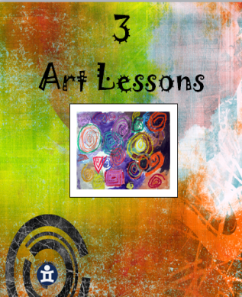

Gr. 3: Lesson 27… Cut-Paper Landscape
Collage & Oil Pastel
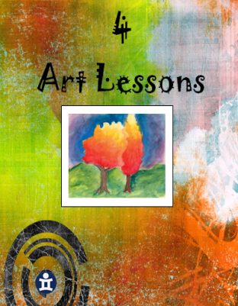
Gr. 4: Lesson 3… Non-Objective Painting
Liquid Tempera Paint
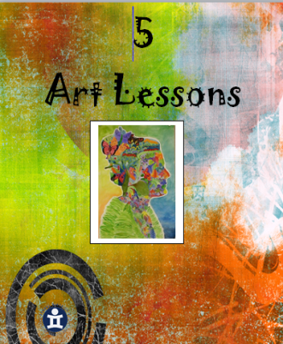
Gr. 5: Lesson 27… Matisse Portrait
Liquid Tempera Paint

Gr. 3 Lesson 27: Cut-Paper Landscape

OBJECTIVE: To use overlapping as an informal perspective technique.

MATERIALS: One 9 x 12 sheet colored paper
Three 4 x 12 sheets of colored paper
Scissors
Glue
Pastels

VOCABULARY: Horizon line – a line which separates the sky and land.
Overlapping – when one object is in front of another. Landscape – a view of outdoors that usually includes land and sky.

MOTIVATION: When you look at the horizon in the city. When you go for a ride in the country, or look out across a large field where there are no houses, the horizon looks as if there is more than one layer, with each layer overlapping the flat land we are standing on. Some hills, or layers, are just grassy while others are covered with forests full of evergreen and deciduous trees of different sizes. In the country you might see farms in the distance with barns, farm houses, fences. Some fields or hills might be snow covered.

Today you are going to create a landscape and try making hills in the distance that overlap each other. You will be cutting and gluing these shapes. This is the collage technique.

ACTIVITY: (1) The 9 x 12 piece of paper will be your background. It does not matter which direction you place your paper. On each of the narrow sheets of paper draw a hill using a pastel. Hills are very different in shape. See if you can make each hill a different shape- they may be pointed or rounded. Make each hill quite high. Cut them out.

(2) Place the hills on the background paper so they overlap. If they are too wide, cut the extra length off. Leave 3-4 cm of space at the bottom of the page for the flat land. Keep moving them around until you like the way they look.

Glue them into place. You should glue the top hill first and the closest hill last.

(3) Cut details for the landscape from your scraps. You can draw these first with your pastels. Two rectangles could make a house or a barn. You could cut out evergreen trees from a triangle. Deciduous trees can be made by cutting strips of paper. You might add animals, vehicles, people, fences, flowers etc. Glue into place.

YOU COULD TRADE SCRAPS WITH OTHER CHILDREN WHO ARE SITTING NEAR YOU.

DO NOT WORRY IF THINGS ARE NOT THE REAL COLOR.

The more details you add to your landscape, the more interesting it will be. Don’t forget things will look smaller in the distance.

(4) If time permits, you could add other details such as doors, windows, leaves, fences, etc.

(5) The sky and the ground may be colored with pastel or left the same color as the construction paper.

EVALUATION: Was overlapping used to create informal perspective?

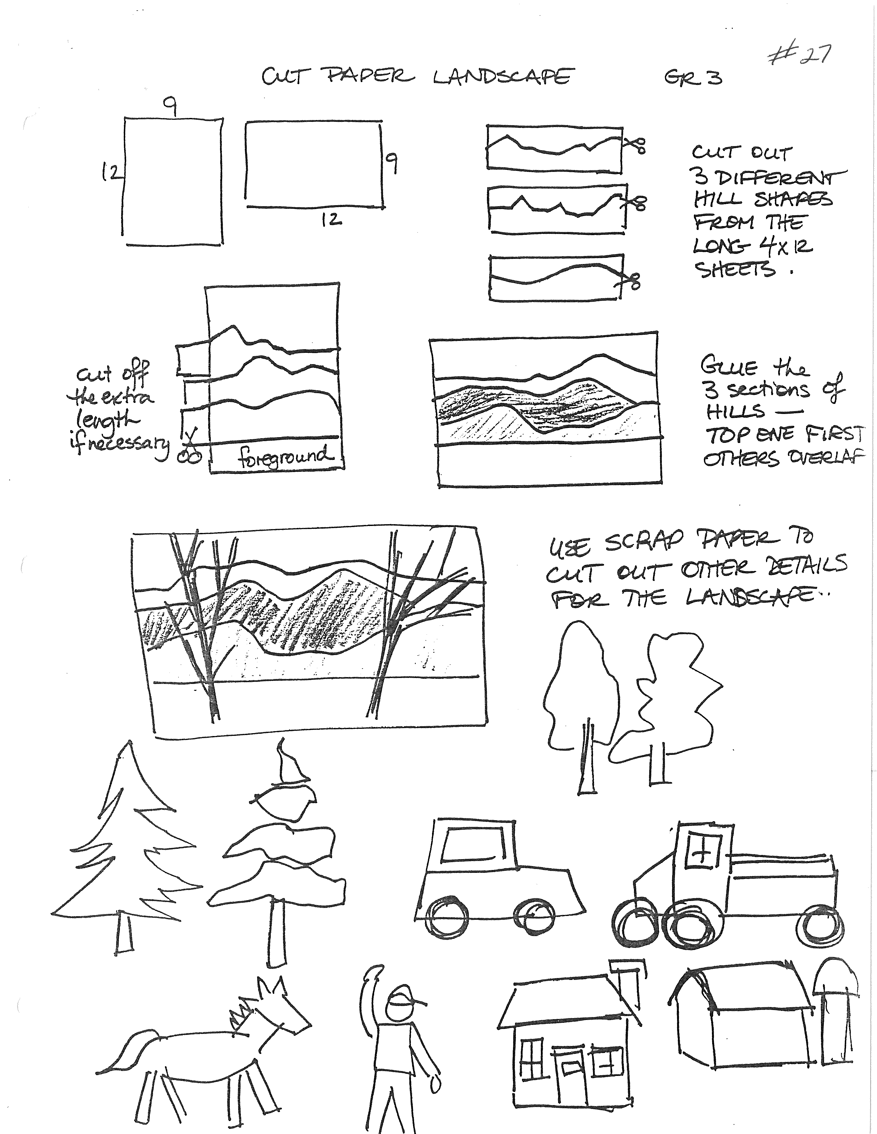

Gr. 4 Lesson 3: Non-Objective Painting

OBJECTIVES: To paint a non-objective work on an unusual-shaped piece of paper.
To limit the use of colour to the three primary colours. To review proper painting techniques.
To identify the elements of non-objective art.

MATERIALS: 18 x 24 white paper
Paint set-up

VOCABULARY: Non-objective Art – art which has no recognizable objects. It is an arrangement of lines, shapes and colours.
Primary Colours – red, yellow, and blue from which all other colours can be made.

MOTIVATION: Some art is realistic looking, while other art is much more imaginative and unusual looking. For example, faces may be so real they look like a photograph or so abstract that they are made from strange shapes and unusual colours.

There are also paintings in which there are no recognizable objects, but only an arrangement of lines, shapes and colours. These are non-objective works of art.

Today, you will paint a non-objective work. We will limit the use of colour to the three primaries plus white and black. What are the three primary colours? (red, yellow and blue). The use of black and white and a few colours in the painting provides a strong contrast and tends to enhance the colour used in a way which in much different than if you were to use many colours.

It is important to note that in any good composition – including a non-objective one – the areas to be left white are carefully chosen. Colours must be repeated in different areas of the composition in order for it to be unified. Black must be used sparingly as it is a very powerful colour.

NOTE: The students will be working on wedge-shaped papers which, when assembled together, may make large abstract painted circles, or interesting shapes. The 18 x 24 papers may be cut before the lesson, or students may cut their own.

The instructions will be given in a very step-by-step format. This will ensure that the paper is divided adequately and that there are a variety of lines and shapes. Even though you are given the same instructions, there are many possible ways to follow directions.

ACTIVITY: (1) Paint neatly, making sharp, clear edges on your shapes. Remember the good painting rules of using thick paint and letting one color dry before touching it with another color.

Use yellow paint for the following steps:

1. Sketch 3 lines starting at the edge of the paper and running off the opposite edge.

2. Paint 3 solids dots (any size), anywhere on the painting.

3. Paint a circle line that touches one dot in some way.

4. Paint 2 angles on the paper from any edge into the painting and then back out to the paper’s edge.

5. Make a curved line that starts at one dot and goes off the paper. From the same dot, make a second curved line which goes off the paper in another direction.

6. Make 2 lines wider with red paint. Note that the line chosen may be a combination of the curved and straight lines. Let the red painted line go from one side to the other.

7. Make any 2 lines wider with blue paint.

8. Cover any 2 lines with black paint.

9. Paint any 3 shapes yellow- remember to choose shapes from different sections of the painting to balance the distribution of colors.

10. Paint any 2 to 3 shapes red.

11. Paint any 2 to 3 shapes blue.

12. Paint 3 small shapes with black.

(2) You may over-paint patterns with bright, thick, red, blue or black paint in 2 to 3 of the shapes in your painting. Be selective. Try not to let the painting become cluttered.

(3) Most of the shapes will be painted. Those left white should be randomly distributed in the composition. The wedges may be assembled in circles or other interesting shapes.

EVALUATION: Have you used good painting techniques- i.e. thick paint, areas filled in?

Does your non-objective painting look balanced and interesting?

Do the white areas enhance the composition? If there are too many white areas fill some in.

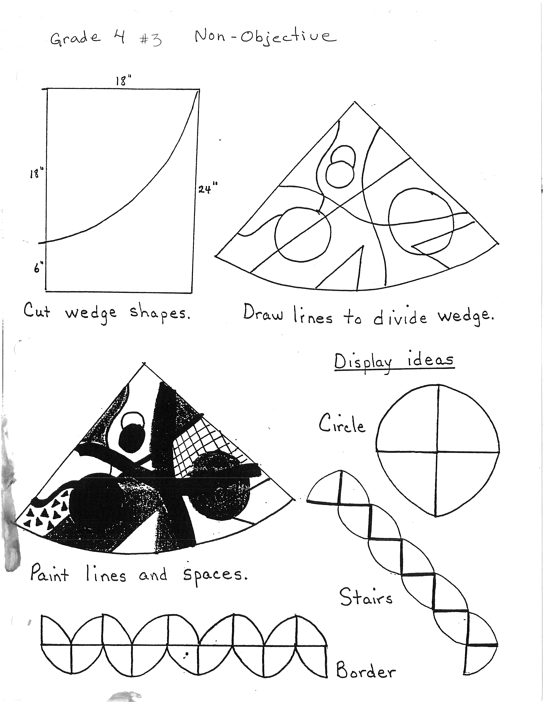

Gr. 5 Lesson 27: Matisse Portrait

OBJECTIVES: To experiment with abstract portraiture.
To introduce Fauvism and the artist Henry Matisse.

MATERIALS: 12 x 18 white paper
Paint set-up

MOTIVATION: Over the past few years you have looked at many reproductions of fine art work and seen the different styles of many artists. In the early 1900’s in France, an art movement known as “Fauvism” developed. The most influential painter responsible for establishing the group was Henri Matisse. He became regarded as the leader.

The Fauve artists did not like the traditional realistic concepts of painting. They wanted to use unusual colors and shapes. Some critics found these unnatural colors very disturbing, particularly in portraits. But the artists used these colors to express moods and feelings. For example, a painting that has a lot of blue may give us a feeling of sadness, while bright orange and yellow may give a feeling of happiness. Fauve artists used wild and unusual colors for effect. Imagine a neon green stripe running down the middle of the face or a piercing yellow cheek with orange eyes. Imagine blue hair with purple outlines. Fauves shocked the public with these wild and wonderful colors. People said this new and expressive art looked like the work of “wild beasts”. (Fauve means “wild beast” in French). Instead of the traditional dark colors or “pretty” pictures, suddenly bright colors and broad brushstrokes made the paintings new and exciting. The brightness seemed not to come from the natural source like the sun or a light, but from the color itself. The resulting effects are full of energy and create strong feelings.

The “Fauve” movement did not last very long, but was very influential on artists who came later.

Today you will experiment with this idea of flat areas of color to see how it influences you.

ACTIVITY: (1) Since you are painting a portrait it might be best to place your paper vertically, but if you feel the horizontal position best suits your portrait, go ahead and place it that way.

(2) Use the yellow paint and the corner of your brush to make a thin line as you draw. Draw the head shape. Heads can be wide at the forehead and narrow at the chin, or reversed. Some faces may be round or rectangular; other faces are wider at the cheek area. Some have square chins, etc. Use your imagination.

(3) Add the facial features. The eyes should be located near the centre of the face shape -often we are tempted to stick them up high.

The bottom of the nose is found half-way between the eyes and the chin. The tops of the ears start at the same height as the eyes. The bottoms of the ears are at the same height as the bottom of the nose.

Be sure that you make your neck wide enough. We often tend to make the neck too narrow.

(4) Draw the hair area with just a few lines. Mark the eyebrows if desired or wait until the face color is dry.

(5) Add a hat if desired. Draw lines for clothing.

(6) Paint. Paint areas with different colors. A cheek in the light might be yellow. A cheek in a shadow might be blue. Skin can be orange, a forehead could be pink and a nose could be green. Do not worry about perfect shapes today. Color is more important. Experiment.

(7) When an area on the face is wet move to the other areas such as the hat, clothes, hair and/or background. You might try different colors on top of each other also.

(8) Add details overtop of the dried areas such as eyebrows, eyelashes, jewelry, details to clothes, etc.

When mixing for new colors try to do it on your paper as much as possible. Place a few large shiny dabs of the dark color on your paper and then paint overtop with the light color. White makes any color lighter (tint). Black makes any color darker (shade).

Red + yellow = orange
Black + red = brown
Blue + green = aqua
Green + yellow = yellow-green
Red + yellow + white = peach
Red + blue + white = mauve

(9) A dark line may be used to outline sections to create emphasis. Matisse often used black or blue to outline sections of his paintings but he did not outline the entire painting.

EVALUATION: Are your colors bright and clear?

Do you have a variety of colors and shapes?

Does your portrait look like it was painted by a “wild beast”?



