A Grade K-2 ARTful Hour...
April. 2014 with Heidi Stoddart
Early Elementary = Personal Expression through Art and Picture Making

“Visual Art Resource Binders K-8” on the DOE Portal

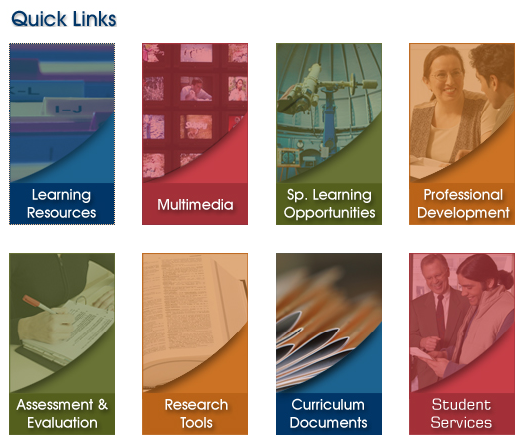
Click on Scroll down to “Visual Arts Resources
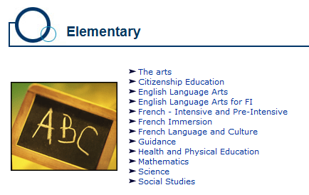
“Learning Resources” Binders K-8” and click on the Grade Level
Under ‘Elementary”, of your choice
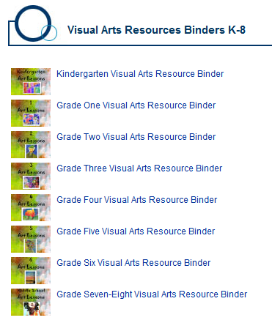
click on “The Arts”

Sample Lessons that we’ll try today…
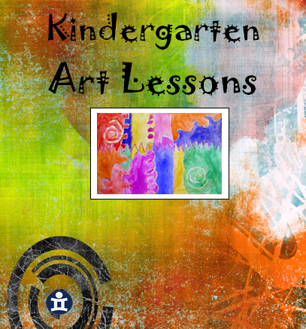
Gr. K: Lesson 24… The Starry Night Resist
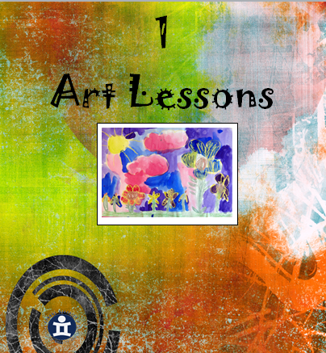
    - Oil Pastel Resist (block tempera paint)

Gr. 1: Supplemental 5A… Textured Surfaces
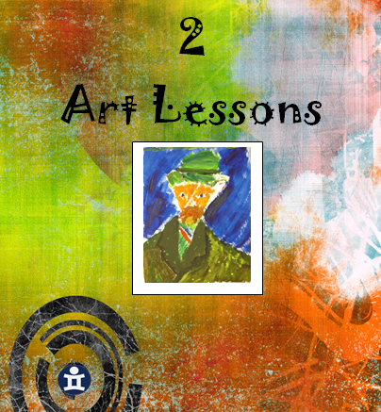
    - Oil Pastel Rubbings & Collage

Gr. 2: Lesson 40… Colourful Daisies
        - Liquid Tempera Paint
Looking at and Responding to/Discussing Art
Visual Literacy is…
- the ability to understand and produce visual messages
- the ability to interpret… and make meaning from information presented in the form of an image
- based on the idea that pictures can be “read”
- learned, just as reading and writing are learned.
-some info retrieved from http://www.kn.pacbell.com/wired/21stcent/visual.html


Sample Discussion Formats:
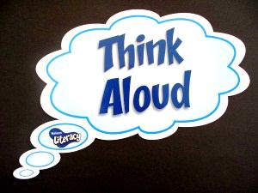
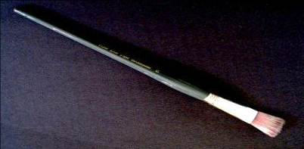
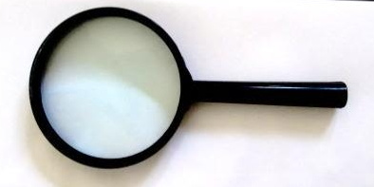
1.

DESCRIBE ANALYZE INTERPRET JUDGE/DECIDE
(what you see) (what the artist did...) (how it makes you feel) (after consideration)
e.g. kinds of line, colours
size of objects, placement…

2. Visual Thinking Strategies (VTS); www.vtshome.org

“What is going on in this picture?”
“What do you see that makes you say that?”
“What more can we find?”

Facilitation Techniques:
  - Paraphrase comments neutrally
  - Point at the area being discussed
  - Linking and framing student comments

“The Arts teach children that problems can have more than one solution and that questions can have more than one answer.”
-Elliot Eisner

Students are asked to:
  - Look carefully at works of art
  - Talk about what they observe
  - Back up their ideas with evidence
  - Listen to and consider the views of others
  - Discuss many possible interpretations

Lesson retrieved from “Visual Arts Resource Binders K-8”
Kindergarten: Lesson 24

The Starry Night Resist

OBJECTIVES: To experiment with the resist technique
To follow simple directions in sequence
To understand how lines show movement
To familiarize students with van Gogh’s style

MATERIALS: 12 X 18 black construction paper
12 X 18 white paper
Pastels
Paint set-up
Scissors & glue

MOTIVATION: Discuss Van Gogh’s “Starry Night”. Observe the color and movement in the painting.

ACTIVITY: (1) On white paper use pastels to draw star shapes (an ‘x’ with a ‘+’ sign going through) in yellow, white or any other colours observed in the painting.

(2) Draw lines extending from the stars to show movement.

(3) Fill in the background with black paint to create a resist.

(4) Trim the edges from the painting using curvy or shapely lines.

(5) Glue trimmed page onto black construction paper.

EVALUATION: Do the stars show movement?
Do they understand the resist technique?

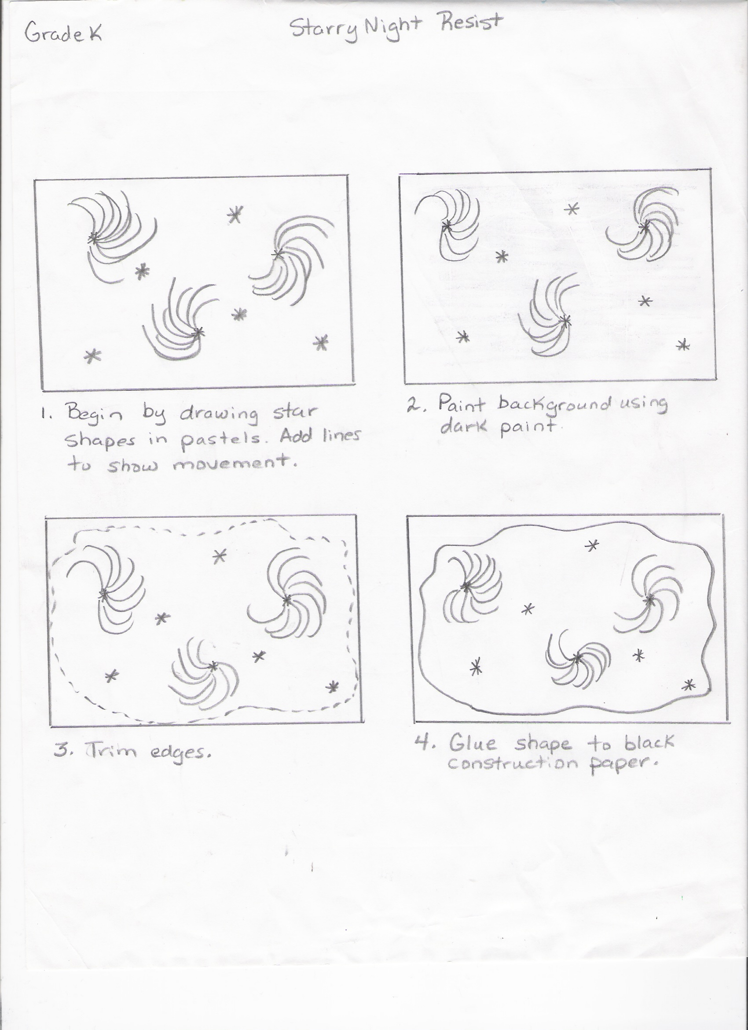

Lesson retrieved from “Visual Arts Resource Binders K-8”
Gr. 1: Supplemental Lesson 5A

Textured Surfaces

OBJECTIVES: To make students aware of the different surface textures of things in their environment.
To introduce students to a simple print technique (rubbing.)

MATERIALS: 12 x 18 white paper
9 x 12 white paper
Scissors
Glue
Pastels (bits of old pastels without papers work well)

MOTIVATION: Show students the photocopy of the wooden boards. Ask them what they think it is a picture of. Then ask them why they think it is a picture of wooden boards. Is it because the surface is all rough and bumpy? Is it because it has lots of lines and ridges and grooves in it? If you were to run your hands across these boards, how would they feel against your skin?

What you feel when you touch a surface is the texture of that object or material. When you run your fingers across sandpaper it feels very different from running your fingers over the pane of glass in a window. You can often imagine how a surface will feel simply by looking at it.

Look around the room right now and find something whose surface you know is smooth. (You will get responses such as the tops of the desks, the paper on the desks, the painted door, the books, etc.) Now look around the room and find something you know will have a rough texture or surface. (Responses may include such things as the carpet, the concrete block walls, some clothing they might be wearing, their hair, etc.)

Show the students the second photocopy and ask them what they think it is a picture of and why. How would it feel to walk over a surface like this in your bare feet?

When you look at a picture, you know the paper is smooth, but there are many different ways you can create the look of different surface textures on your page. We are going to experiment with one way today, known as “rubbing”.

NOTE: It would be beneficial if you could bring some objects in with different textured surfaces such as bark, velvet, steel wool, pebbles, sandpaper.

ACTIVITY: (1) Find a surface in the room that has a texture you like. Next put your 12 x 18 paper over top of that surface. Then, using the flat side of your pastel, rub back and forth across the area you want on your page. (The teacher must demonstrate these steps.) When you are finished, you will have a print of the surface you just rubbed.

(2) Look at your large sheet. Is there any texture on it that might suggest a tree, a brick house, a wooden barn, a bumpy road, a smooth shiny car, or a furry animal? From this large sheet you will cut out simple shapes such as a square and a triangle to create a house; a long curvy strip to suggest a winding road; long strips for trunks or branches of trees; simple clouds, bush shapes. It will be easier to first draw the shapes on top of the textured area you want and then cut them out. Make sure your main shapes are quite large.

(3) Arrange these shapes on top of your 9 x 12 piece of paper to create a picture or scene. If you have a very tall building or tree you will have to run your smaller sheet vertically for the shapes to fit on properly.
Try several different arrangements first before you glue down any pieces.

Once all the pieces you want to use have been glued down, you can cut out smaller pieces to glue down on top of them. For example, you may want to add doors, windows, curtains, leaves on trees, etc. You can also use your pastels to add any small details you would like.

Don’t forget to think about what textures you are choosing for your cut out pieces. For example, what does the texture you choose for your building appear to be made of – wood, cement or brick?

NOTE: This is an experimental lesson. Let the children explore, touch and manipulate the material. Do not worry about finished results.

(4) Once you have all your shapes glued into place, you can consider the background. You will want to fill the entire background in solid. You can draw other buildings, trees, or people. You may want cars or trucks. You will need the ground or sky. There might be mountains or hills in the background

EVALUATION: How many different types of textured surfaces can you see in the class?
Did you create rubbings from textured surfaces?
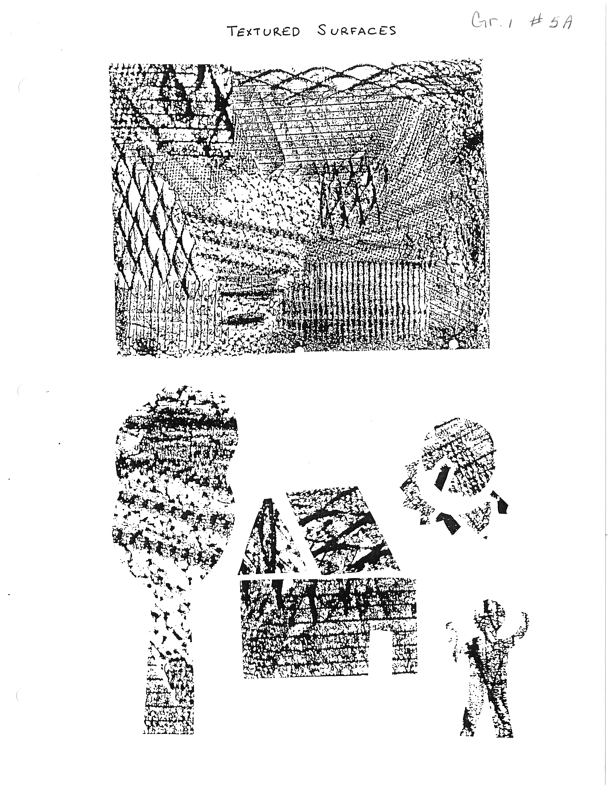

Lesson retrieved from “Visual Arts Resource Binders K-8”
Gr. 2: Lesson 40

Coloured Daisies

OBJECTIVE: To practice basic painting techniques.

MATERIALS: 12 x 18 white paper
Paint set-up

MOTIVATION: Daisies are one of our early summer wild flowers. Children seem to enjoy picking bouquets of them. They also seem to enjoy pulling off the petals to find answers to secret questions.

Most of the wild daisies are white with yellow centers. A flower that looks very much like the daisy is the Black-Eyed Susan. It has yellow petals with a very dark brown centre.

Scientists have done many experiments using flowers. They have been able to produce cultivated daisies that have different colored petals such as light blue, pink and orange.

You might try your own scientific experiment with wild daisies. Try placing some daisies in a glass of fresh water to which a few drops of food coloring have been added. As the flowers drink up the colored water their petals will change color.

Today you are going to paint a bouquet of daisies. You may pretend you are a scientist and that you have produced daisies that come in any color you wish.

ACTIVITY: (1) Place your paper in whichever direction you wish. If you want a wide bouquet, place your paper like the horizon – horizontally. If you want a tall bouquet, place your paper vertically.

(2) Use the corner of your brush and the yellow paint to make a very thin line as you draw. To draw a daisy, begin by drawing a circle as large as a small orange for the centre. Draw one petal near the top of the circle and then one near the bottom. Go back and draw another near the first top one and then one near the bottom one.
Continue in this manner until the circle is surrounded with petals. Do not worry if some are long and others are short or if some are skinny and others are fat. Nature does not make things perfect.

(3) Draw two or three more daisies in this manner. Try not to put them in a straight line. Some could be on tall stems, while others are on short ones. Do not worry if parts of one daisy go behind another daisy. Do not worry if parts go off the page. Try to have a least one go right to the top of your page.

(4) Paint the petals whatever color you choose. With thick paint, fill in one petal at a time. To get thick paint, pull your brush backward across the paint many times. You may paint all the daisies the same color or you may paint each one a different color.

You might want to mix some other flowers in with your daisies. What other flowers could you include? You might like some wild roses, blue violets or buttercups. You can experiment with different ways to add some additional flowers to create more variety and interest. You might want to put irregular circles one inside the other to create a rose. You might want to paint some small dabs together in a cluster or some thin lines radiating out from a centre to create different effects.

(5) While the petals are drying, add the parts of the stems that you see and the leaves. The leaves of a daisy have a zigzag edge. Perhaps you might only be able to see the tops of some leaves.

(6) Paint the centers of the daisies.

(7) Paint the background. This is often when children become lazy. Please take your time and let the brush slide carefully around each petal. It would be better to leave little tiny bits of white showing than to paint over your petals.

EVALUATION: Did I practice proper painting techniques?



