**A Grade K-2 ARTful Hour...**

May 2012

With Heidi Stoddart

Early Elementary = Personal Expression through Art and Picture Making

1. 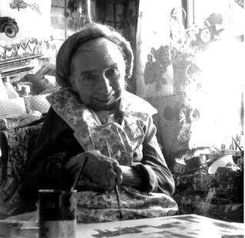**Maud Lewis & Painting**

**MATERIALS:**

**Session 1 – Maud Lewis & Planning a Picture**

-Powerpoint or samples of Maud Lewis’ artworks

-Possible props for “Viewing & Discussing Art”

-paper (e.g. 8”x10”)

-wax crayons

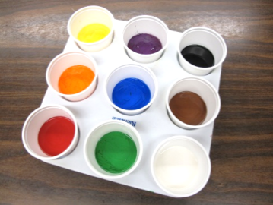[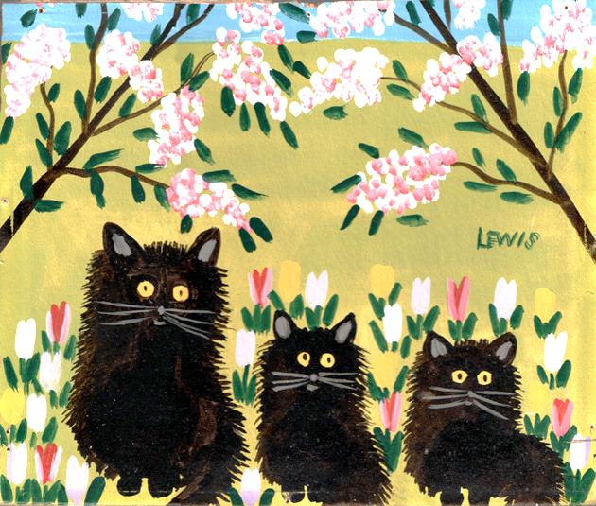](http://4.bp.blogspot.com/-s9PWXk1rkkk/T0Am_4614jI/AAAAAAAAC9g/gV0dXP9XROc/s1600/mlcat.jpg)

**Session 2 – Painting**

-canvas or heavy cartridge paper (e.g. 8”x10”)

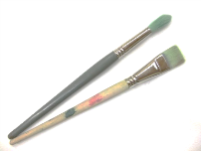-liquid tempera paint (variety of colours)

-welled palettes for paint

-paint brushes (variety of sizes)

-water containers

-paper towel

* Teacher Tip: *It helps to have the materials ready ahead of time for painting, but not yet distributed to students as it can be distracting during the discussion/demonstration parts of the lesson.*

**Session 1 – Maud Lewis & Planning a Picture**

* Introduce the work of Maud Lewis (see Powerpoint available at www.elementaryvisualart.weebly.com)

|  |
| --- |
| **Background Info about Maud Lewis**  “I know of an artist who loved to paint. I would like to introduce you to this artist today…”  Share a picture of this artist and introduce Maud Lewis.   * she was born in South Ohio, Nova Scotia, in 1903 (-1970 = 67 years) * she was very small, and suffered from rheumatoid arthritis, which affected her hands and made it hard for her to hold a paintbrush, but she always looks happy in pictures and she LOVED to paint * when she was little, she like to play at home with her brother * she started painting because her Mother asked her to make some Christmas cards * when she grew up, she married a fish peddler named Everett * they lived in a tiny little house with no plumbing and no electricity * while he travelled around selling fish, she went along and sold her paintings * she liked to paint things she saw around her, like her pets, and OUTDOOR SCENES of things she saw near her house, like the garden, hills, trees, animals and fishing boats * Maud would draw the outline of her picture first, then apply the paint directly from the tube without mixing. * Maud painted on EVERYTHING… old boards, her kitchen cupboards, shutters * she painted for the JOY of adding colour to her life! * Now, Maud and Everett’s little house has been moved to the Art Gallery of Nova Scotia, where it is on display for anyone to see! * Today, she is one of Canada’s best known and most loved folk artists |

SESSION 1 PROCESS

**VIEWING ART BY MAUD LEWIS…**

1. DESCRIBE … (Prop: MAGNIFYING GLASS) What do you see in this picture?

2. ANALYSE… (Prop: PAINTBRUSH) What colours did the artist use? What seems really close in the foreground? What seems far, far away in the background? Do you see any canvas showing through? (Fill the canvas with paint… beautiful colours and shapes.)

3. INTERPRET… (Prop: HEART) Pretend we could step right into this painting; imagine we are right there. What sounds would you hear? What would you smell?

4. RESPONSE/JUDGE/DECIDE… (Prop: THINK BUBBLE)

What would you call this painting? Make up a title for it & print on ‘think bubble’ worksheet

**CREATE…**

* Now YOU get to think about making your own painting!
* Today, you will draw your IDEA on a piece of paper with crayons.
* Next week, you will PAINT your idea on canvas… a REAL PAINTING just like Maud Lewis.
* Start by thinking of something that is special to you, something YOU like!

Possibilities…

*Favourite animal, thing, people or place…*

*Animal = your pet, or an animal you love (dog, cat, hamster, fish, dinosaur, giraffe, turtle…)*

*People = your family, your friends…*

*Place = your school, your home, or your Nanny and Grampie’s farm, or the playground, or your backyard, or the beach…*

*Thing = favourite food, favourite toy, a bike, trucks, boats, dinosaurs, outer space, your favourite thing to do (playing soccer, skipping, playing outside, reading…)*

*Nature = a garden, flowers, a tree, a rainbow, a butterfly, a frog, a whale…*

ORIENTATION of the canvas/paper – the artist decides which way!

PLAN… (using crayon on paper, name on back first!)

1. Something you like

2. Horizon Line

3. Fill the space with bright colours

SESSION 2 PROCESS

**CREATE…**

1. Gather students and review the goal: “I want to make a painting of…” Invite students to share their ideas based on their plans/drawings from last time.
2. Introduce the materials, including canvas/paper (be sure to orient it the way you need it), paint brushes (review how to hold to control the paint), and paint.
3. DEMONSTRATE how start by ‘outlining’ the main shape with the paint, then filling it in so you can’t ‘see through’ the object. Show how to clean the brush between colours (eg., ‘wiggle’ against the bottom of the water container, ‘press/press’ against the inside edge of the container, wipe’ with paper towel). Wait to add details, like eyes or polka dots, until the paint has dried a bit, so go on to the background next… Remember to include ‘ground’ if required (e.g., is that truck on pavement, gravel, dirt or grass?) and to fill the canvas with paint. Show how to go back to add details with a small brush at the very end.
4. Distribute paint brushes to practice how to hold (“Just like my pencil in my printing hand.”), and to pretend to paint & wash brush (acting out the motions).
5. Students head back to work space, print name on the back of their paper, and start painting.
6. Clean-up:

* Brushes in water container to soak
* Painting to drying area
* Paper Towel in Garbage/Compost
* Wash Hands
* Draw or read art books

1. [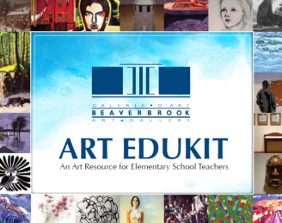](http://www.beaverbrookartgallery.org/documents/BeaverbrookArtGallery_Edukit_2011_En.pdf)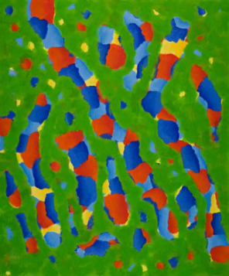 **EDUKIT…**

“Playful Patterns – A World of Colour”

See Beaverbrook Art Gallery’s “EduKit” Resource (attached)

Pages 113-122

**3. Kandinsky… Bubble Prints**

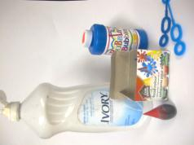**MATERIALS...**

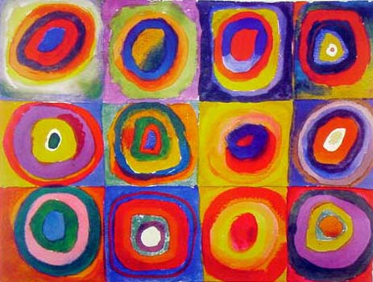-bubbles

-dish detergent

-food colouring

-large sheets of paper (e.g. 12”x24” cartridge paper)

**TEACHER TIPS:**

* *Have students print their names on the back of the paper before starting!*
* *Pre-mix the bubbles with a bit of dish detergent and at least 24 drops of food colouring (more needed for yellow)*

**INTRO…**

* Introduce works by Wassily Kandinsky. What colours do you see? What shapes? Do you notice any patterns?

CREATE

**PROCESS…**

* Gently blow one bubble at a time onto your paper. Observe what happens when it comes in contact with the paper. Experiment with different colours and try to use the space well.

**More Resources about Famous Artists…**

* Mightybooks.com “[Art & Music](http://www.mightybook.com/art_and_music.html)” (http://www.mightybook.com/art_and_music.html)
* Mightbooks.com “[Museum of Great Art](http://www.mightybook.com/MightyBook_free/artgallery/gallery.html)” (http://www.mightybook.com/MightyBook_free/artgallery/gallery.html)
* Davis Arts’ “[Artist Birthdays](http://www.davisart.com/portal/teacherresources/T_resourcesDefault.aspx?curPage=ArtistBirthdays)” (http://www.davisart.com/portal/teacherresources/T_resourcesDefault.aspx?curPage=ArtistBirthdays)
* “Getting to Know the World’s Greatest Artists” series (books & [videos](http://www.gettingtoknow.com/videos.htm)) (http://www.gettingtoknow.com/videos.htm)